MySQL Assignment - 1

1) Write a query to get a Product list (id, name, unit price) where current products cost less than $20.

select ProductID, ProductName, UnitPrice from products where UnitPrice < 20 and Discontinued = 'n';

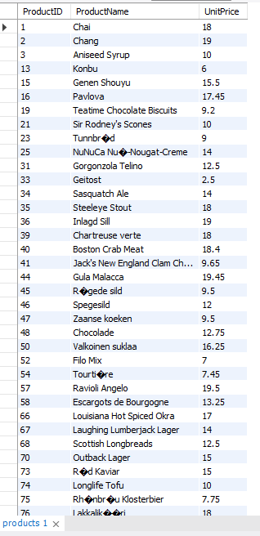

2) Write a query to get Product list (id, name, unit price) where products cost between $15 and $25

select ProductID, ProductName, UnitPrice from products where UnitPrice>=15 and UnitPrice<=25;

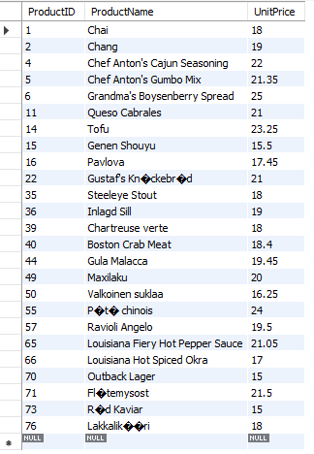

3) Write a query to get Product list (name, unit price) of above average price.

select ProductName, UnitPrice from products where UnitPrice > (select avg(UnitPrice) from products);

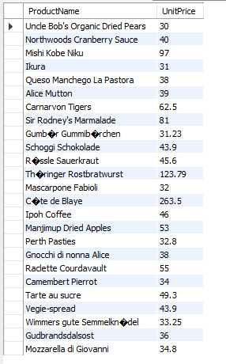

4) Write a query to get Product list (name, unit price) of ten most expensive products

select ProductName, UnitPrice from products order by UnitPrice desc limit 10;

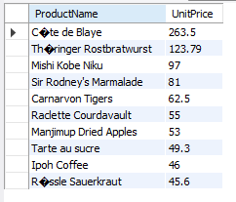

5) Query to count current products & Query to count discontinued products

select count(\*), Discontinued as isDiscontinued from products group by Discontinued;

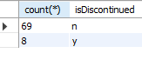

6) Write a query to get Product list (name, units on order , units in stock) of stock is less than the quantity on order

select ProductName, UnitsOnOrder, UnitsInStock from products where UnitsInStock < UnitsOnOrder;

